**Ques 1 : Hello World RESTful Web Service**

**--application.properties**

server.port=8083

**--HelloController.java**

package com.cognizant.springlearn.controller;  
  
import org.slf4j.Logger;  
import org.slf4j.LoggerFactory;  
import org.springframework.web.bind.annotation.GetMapping;  
import org.springframework.web.bind.annotation.RestController;  
  
@RestController  
public class HelloController {  
  
 private static final Logger *LOGGER* = LoggerFactory.*getLogger*(HelloController.class);  
  
 @GetMapping("/hello")  
 public String sayHello() {  
 *LOGGER*.info("Start");  
 String message = "Hello World!!";  
 *LOGGER*.info("End");  
 return message;  
 }  
}

**--SpringLearnApplication.java**

package com.cognizant.springlearn;  
  
import org.springframework.boot.SpringApplication;  
import org.springframework.boot.autoconfigure.SpringBootApplication;  
  
@SpringBootApplication  
public class SpringLearnApplication {  
 public static void main(String[] args) {  
 SpringApplication.*run*(SpringLearnApplication.class, args);  
 }  
}

**Output :**

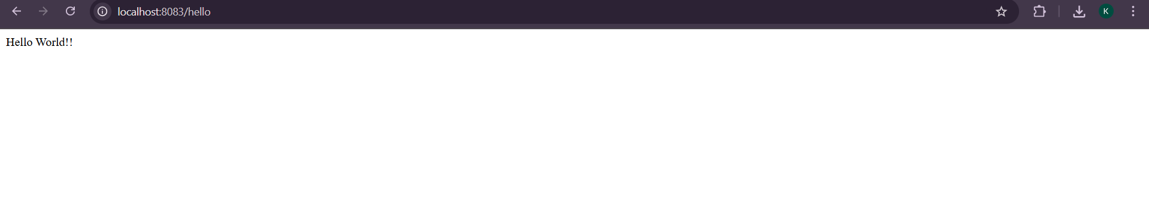

**Console Log Output :**

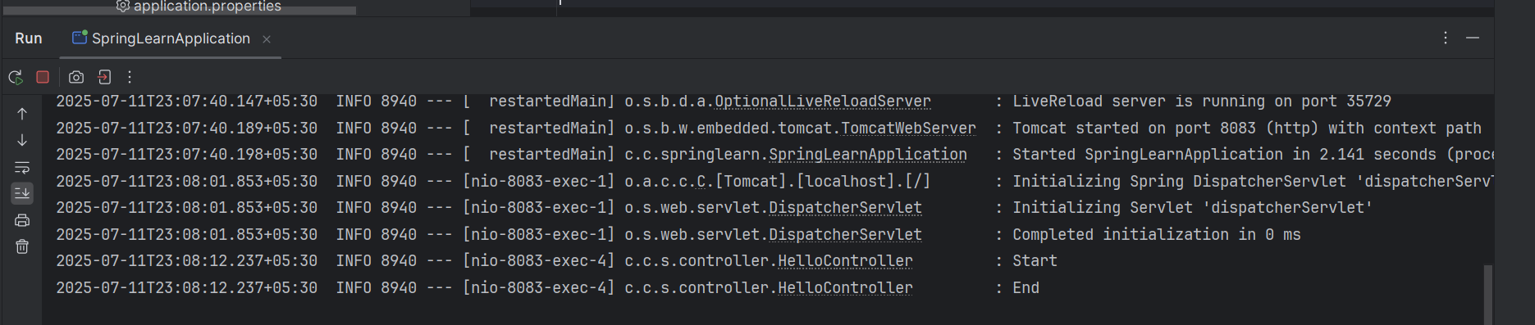

**Ques 2 : REST - Country Web Service**

--country.xml

<?xml version="1.0" encoding="UTF-8"?>  
<beans xmlns="http://www.springframework.org/schema/beans"  
 xmlns:xsi="http://www.w3.org/2001/XMLSchema-instance"  
 xsi:schemaLocation="  
 http://www.springframework.org/schema/beans  
 http://www.springframework.org/schema/beans/spring-beans.xsd">  
  
 <bean id="country" class="com.cognizant.springlearn.model.Country">  
 <property name="code" value="IN"/>  
 <property name="name" value="India"/>  
 </bean>  
  
</beans>

**--Country.java**

package com.cognizant.springlearn.model;

public class Country {

private String code;

private String name;

public Country() {

System.out.println("Inside Country Constructor.");

}

public String getCode() {

System.out.println("Inside getCode");

return code;

}

public void setCode(String code) {

System.out.println("Inside setCode");

this.code = code;

}

public String getName() {

System.out.println("Inside getName");

return name;

}

public void setName(String name) {

System.out.println("Inside setName");

this.name = name;

}

@Override

public String toString() {

return "Country [code=" + code + ", name=" + name + "]";

}

}

**--CountryController.java**

package com.cognizant.springlearn.controller;

import com.cognizant.springlearn.model.Country;

import org.slf4j.Logger;

import org.slf4j.LoggerFactory;

import org.springframework.context.ApplicationContext;

import org.springframework.context.support.ClassPathXmlApplicationContext;

import org.springframework.web.bind.annotation.RequestMapping;

import org.springframework.web.bind.annotation.RestController;

@RestController

public class CountryController {

private static final Logger LOGGER = LoggerFactory.getLogger(CountryController.class);

@RequestMapping("/country")

public Country getCountryIndia() {

LOGGER.info("Start");

ApplicationContext context = new ClassPathXmlApplicationContext("country.xml");

Country country = context.getBean("country", Country.class);

LOGGER.info("End");

return country;

}

}

**Output :**

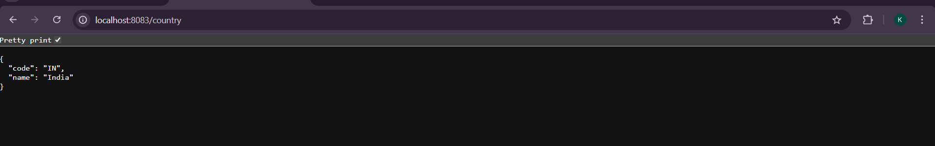

**Ques 3 : REST - Get country based on country code**

**--** **country.xml**

<beans xmlns="http://www.springframework.org/schema/beans"

xmlns:xsi="http://www.w3.org/2001/XMLSchema-instance"

xsi:schemaLocation="http://www.springframework.org/schema/beans

http://www.springframework.org/schema/beans/spring-beans.xsd">

<bean id="countryList" class="java.util.ArrayList">

<constructor-arg>

<list>

<bean class="com.cognizant.springlearn.model.Country">

<property name="code" value="IN"/>

<property name="name" value="India"/>

</bean>

<bean class="com.cognizant.springlearn.model.Country">

<property name="code" value="US"/>

<property name="name" value="United States"/>

</bean>

<bean class="com.cognizant.springlearn.model.Country">

<property name="code" value="DE"/>

<property name="name" value="Germany"/>

</bean>

<bean class="com.cognizant.springlearn.model.Country">

<property name="code" value="JP"/>

<property name="name" value="Japan"/>

</bean>

</list>

</constructor-arg>

</bean>

</beans>

**-- CountryService.java**

package com.cognizant.springlearn.service;

import com.cognizant.springlearn.model.Country;

import org.springframework.context.ApplicationContext;

import org.springframework.context.support.ClassPathXmlApplicationContext;

import org.springframework.stereotype.Service;

import java.util.List;

@Service

public class CountryService {

public Country getCountry(String code) {

ApplicationContext context = new ClassPathXmlApplicationContext("country.xml");

List<Country> countries = context.getBean("countryList", List.class);

return countries.stream()

.filter(country -> country.getCode().equalsIgnoreCase(code))

.findFirst()

.orElse(null);

}

}

**-- CountryController.java**

package com.cognizant.springlearn.controller;

import com.cognizant.springlearn.model.Country;

import com.cognizant.springlearn.service.CountryService;

import org.slf4j.Logger;

import org.slf4j.LoggerFactory;

import org.springframework.beans.factory.annotation.Autowired;

import org.springframework.web.bind.annotation.*;

@RestController

public class CountryController {

private static final Logger LOGGER = LoggerFactory.getLogger(CountryController.class);

@Autowired

private CountryService countryService;

@GetMapping("/countries/{code}")

public Country getCountry(@PathVariable String code) {

LOGGER.info("Start");

Country country = countryService.getCountry(code);

LOGGER.info("End");

return country;

}

}

**Output :**

